Practical 12 : Flask

Step 1: Install python

Step 2: Installation of flask

Command : pip install flask

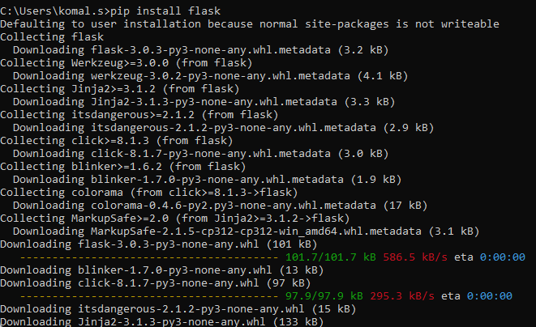

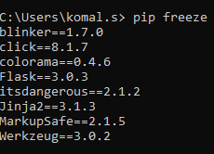

Task 1: Create a new file

from flask import Flask

# Flask constructor takes the name of

# current module (__name__) as argument.

app = Flask(__name__)

# The route() function of the Flask class is a decorator,

# which tells the application which URL should call

# the associated function.

@app.route('/')

# ‘/’ URL is bound with hello_world() function.

def hello_world():

    return 'Hello World'

# main driver function

if __name__ == '__main__':

    # run() method of Flask class runs the application

    # on the local development server.

    app.run()

Output:

Click on: Running on <http://127.0.0.1:5000>

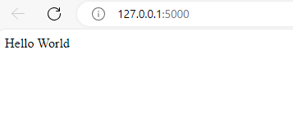

Task 2: Connect your application using SQLAlchemy to PostgreSQL. Perform CRUD queries.